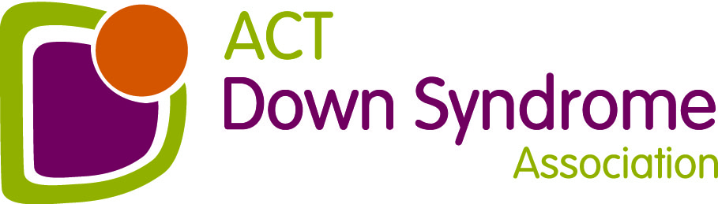
ACT Down Syndrome Association Inc
A.B.N. 69 287 334 664
Bldg 1, Pearce Community Centre, Collett Place, Pearce

PO Box 717 Mawson ACT 2607
Tel: (02) 6290 0656

Email: admin@actdsa.org.au

The Alderson Family Award 2023 – Nomination Form
Category: 18 Years +

The following guidelines apply:
- Nominee must be a person with Down syndrome.
- Membership of the Association is not a prerequisite for the award.
- Achievement for a person with Down syndrome must be significant in the context of the nominee’s life, not necessarily the wider community. Examples may be (but are not limited to): finishing school or achieving a good school report, confidently catching public transport, learning how to play a new sport or instrument, getting a job or volunteering for an organisation.
- The decision of the Association will be final.
- Nominations must be in writing and be received by the ACTDSA by 8 March 2023.
Nominee Information

Name of Nominee

Home Telephone Number

Work Telephone Number

Mobile Telephone Number

Email address

Nominator Information

Name of Nominator

Address

Home Telephone Number

Work Telephone Number

Mobile Telephone Number

Nomination for the Alderson Family Personal Achievement Award

Short Description of the Achievement

How long did it take to achieve this goal?

What is the significance of achieving this goal?

How has this changed the person’s life?

If insufficient space is provided, please attach additional page/s to complete your nomination.

Thank you for your nomination, please send to ACTDSA, PO Box 717, MAWSON, ACT 2607 or email to: admin@actdsa.org.au by 8 March 2023.

