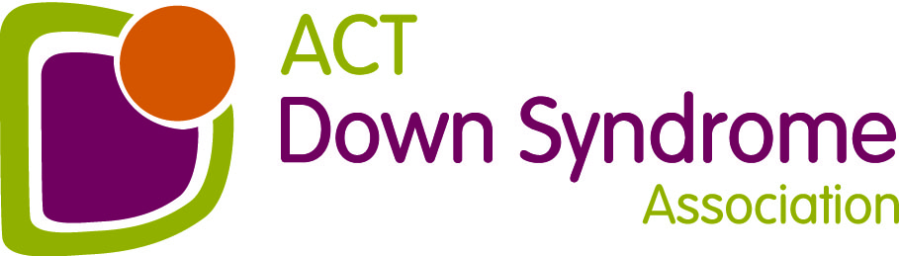
ACT Down Syndrome Association Inc
A.B.N. 69 287 334 664
Bldg 1, Pearce Community Centre, Collett Place, Pearce

PO Box 717 Mawson ACT 2607
Tel: (02) 6290 0656 Email: admin@actdsa.org.au
Nomination for the
Alderson Family Community Contribution Award 2023

The following guidelines apply:
- Nominee must be an individual, organisation or business who has contributed to the community and/or people with Down syndrome in some way.
- Membership of the Association is not a prerequisite for the award.
- Examples of contributions could be (but are not limited to) providing meaningful employment to a person with Down syndrome. Providing work experience or volunteering opportunities to a person with Down syndrome. Providing education or training to a person with Down syndrome, their families, friends or support people.
- The decision of the Association will be final.
- Nominations must be in writing and be received by the ACTDSA by 8 March 2023.
Nominee Information

Name of Nominee

Home Telephone Number

Work Telephone Number

Mobile Telephone Number

Email address

Nominator Information

Name of Nominator

Address

Home Telephone Number

Work Telephone Number

Mobile Telephone Number

Referee Information

Name of Referee

Email Address

After Hours Contact Number

Business Hours Contact Number

Mobile Telephone Number

Nomination for the Alderson Family Community Contribution Award

Short Description of the Community Contribution

How long has the organisation contributed to the community?

What are the outcomes of this organisation’s contribution?

If insufficient space is provided, please attach additional page/s to complete your nomination.

Thank you for your nomination, please send to ACTDSA, PO Box 717, MAWSON, ACT 2607 or email to: admin@actdsa.org.au by 08 March 2023.

