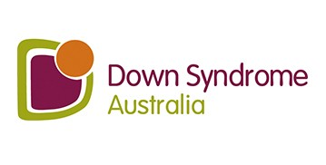
South Australian Information Service
Survey 2020

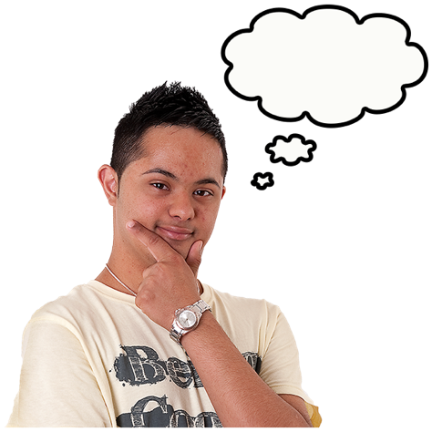


This is an Easy Read survey.

It is for people who live in South Australia.

It has questions about a new information service.

About the survey


Who is doing this survey?

Down Syndrome Australia is doing the survey.

Our job is to speak up for people with Down syndrome.

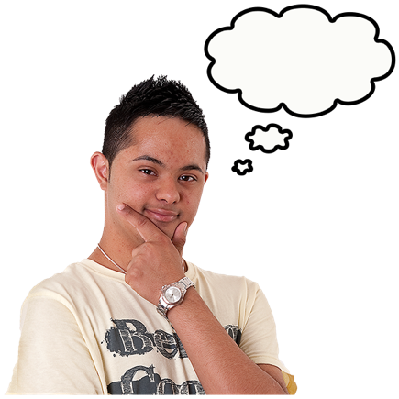Why are we doing the survey?

We are starting a new information service in South Australia.

We want to hear from you about what information you need.

We also want to know how you want to connect with us.

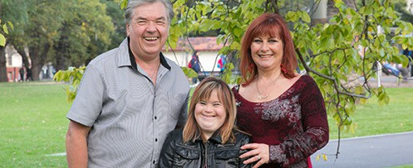
Who can fill in the survey?

People with Down syndrome and their families who live in South Australia.

This is the short Easy Read survey. There is a longer survey too.


Important information before you start

You can take some time to think about whether you want to do the survey or not.


You can choose if you want to answer all the questions in the survey or not.

You can choose just to do some of the questions if you like.


You can decide if you will put personal information in the survey.

Personal information is information about you, like your name or your address.

It is your choice.


If you give us your personal information, we will keep it safe and private.

You can ask someone to help you answer the questions if you want to.

You can tick boxes and write or draw your answers.

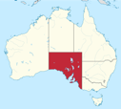

Do you live in South Australia?

Yes

No

Are you a person with Down syndrome?

Yes

No

If you are not a person with Down syndrome, please tell us who you are. (For example: Parent, other family member, friend, support person.)

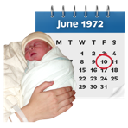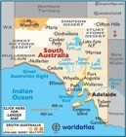

How old are you?

Do you live in Adelaide?

Yes

No

If you don’t live in Adelaide, where do you live?

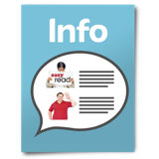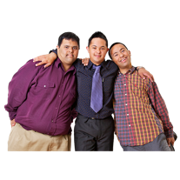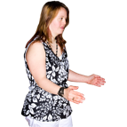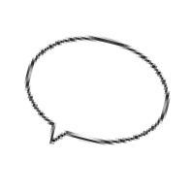

Can you find the information you need?

Yes No
Sometimes

Do you feel connected with other people in the Down syndrome community?

Yes No
Sometimes

Would you like to tell us what kind of information service you need?

Yes

No

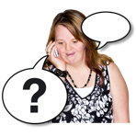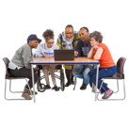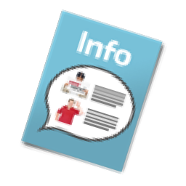

What is the best way for you to tell us?

Surveys
Email

In a group
Phone

What do you think is the main information that is missing in South Australia?

What do you think is missing when it comes to connecting with other people?

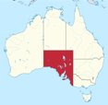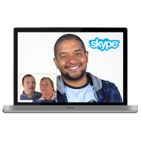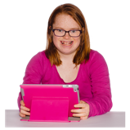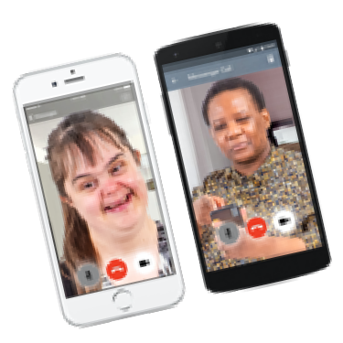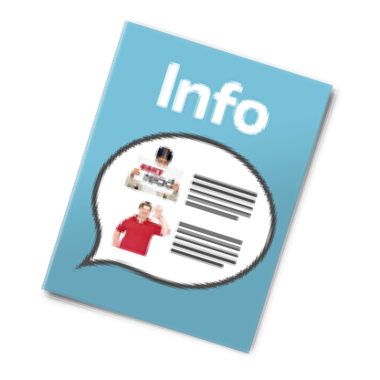

What do you think is missing when it comes to the support you need?

COVID 19 means we can’t run events or workshops in person. Would you like to connect online, such as with Zoom?

What kind of online events would you like?

Social Information
Both

If you don’t live in Adelaide, are there any problems that affect you because you live in another area?

How would you like to get information from us?

Facebook Email
By mail Newsletter

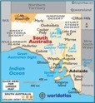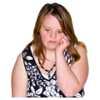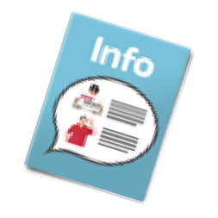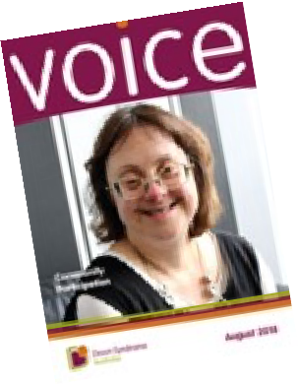

Would you like to get the Down Syndrome Australia magazine? It is called Voice. It is free.

Yes

No



If you write your home address here we will send you free copies of Voice magazine.

If you write your email address and phone number here we will let you know what is happening and other news and information.

We will keep your information private. We won’t give it to anyone else.

10

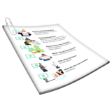Here is what we will do with the things you told us.

We will put together all the information we get from the survey.

It will help us work out how to make a good information service for people with Down syndrome and their families in South Australia.

The survey is finished. Thank you for helping us!

You can email it to: infoSA@downsyndrome.org.au or you can post it to: Down Syndrome Australia
18/71 Victoria Crescent Abbotsford VIC 3067

11

