Brisbane World
Down Syndrome Congress 2022

By Jesicca Brown
In November 2016, Down Syndrome Australia was
excited to announce that we were selected by Down Syndrome International to host the 2022 World Down Syndrome Congress in Brisbane.
This international conference is held every two years and brings together people with Down syndrome, family members, researchers and service providers from around the world to showcase the latest research and discuss models of best practice. It is also a great opportunity for advocates to share the lived experience of Down syndrome.
Chair of DSA Angus Graham OAM notes that hosting the congress in Brisbane will ‘create wonderful opportunities for inclusiveness, learning and community on a scale rarely seen by people with Down syndrome in the southern hemisphere’.
The recent congress in Glasgow in July this year was an important step in DSA’s planning for the Brisbane congress. We appointed our Professional Conference Organiser earlier this year and Glasgow was our first opportunity to bring together the team who will be delivering the congress in Brisbane.
DSA also had an exhibition stand for the first time at an international conference. We were excited to provide that visible presence and show people from all over the world the quality of the resources we offer, and encourage them to come to Australia in 2022.
The congress in Glasgow was also a fantastic opportunity for DSA to learn more about how a world congress is run. Whilst representatives of DSA have been to congresses before, this time we had a different perspective and the planning committee took away many valuable insights such as what is generally included or not included. Since our return, the planning and work behind the scenes has been steaming ahead.
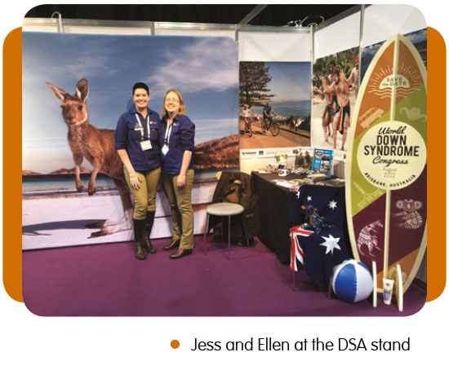Did you know that DSA ran a competition for people with Down syndrome to help us design the congress logo? It is vital to us that people with Down syndrome play a large part in the planning, development and execution of the Brisbane congress, so it made sense to start this process from the very beginning. Entries for the competition closed at the end of November and we aim to choose a winner by the middle of December. We plan to announce the winner and the final logo design next year on World Down Syndrome Day at our annual Parliamentary Morning Tea.
We have a great vision and have set high standards for our delivery of the 2022 WDSC in Brisbane, but your input will make it even better! We would love to hear from you at wdsc2022_info@downsyndrome.org.au or, if you prefer, send us a Facebook message. Tell us your ideas and what you would like to see. If you have been to a past congress, what would you like us to do differently? What information would you like to have available? What types of exhibitors and exhibitions would you like to see? How would you like to be involved? We are looking forward to hearing what you have to say about how you would like the congress to run.
Finally, don’t forget to register your interest in the congress by entering in your details at our congress landing page, www.wdsc2022.org.au, to keep up to date with all the congress news.
Jessica Brown is administration coordinator for DSA and a member of the planning committee for the WDSC 2022 in Brisbane.

