A simple guide to estate planning

By Andrew Papaleo, Lawyer

A guide to help you achieve a future for your family member with Down syndrome that is certain, secure, and sustainable.

STEP 1 – CREATE YOUR PLAN
Ask yourself:
- What are my goals?
- What are the goals and needs for the person now, and into the future?
- How does the person communicate or express their needs?
- Is it reasonable to expect that they will outlive me?
- If so, what will they need once I am gone?
- What can I do now to make the necessary arrangements before then?
The arrangements that you will need to make for the person will depend upon their abilities, the support and resources available, and your wishes for them in the future.
If your family member is reasonably capable of managing their own affairs, it may well be that there is no need for a special arrangement and you can plan in the same manner in which you would have, had they not been born with a disability.
However, a person with a disability is likely to require a special arrangement if:
- the disability affects mental capacity, including decision- making; and/or
- you want to control how assets and financial resources are used for their benefit in the future.
By discussing the issues that are particular to your situation with your lawyer, your financial adviser, and your family member’s health professionals, you will be able to adapt those arrangements in accordance with the person’s needs.

STEP 2 – UNDERSTAND YOUR OPTIONS
Documenting your plan is essential to ensure that it is implemented as you intended.
There are a number of options available to you.

Making a will
A will is a document that defines how you would like your assets distributed following your death; how that distribution will occur; and the person/s or organisation who will be responsible for carrying out your wishes.
It is important to have a will to ensure certainty and security for yourself and your family, and to control how your assets will be distributed following your death.

Is a will enough to reasonably support my family member in the future?

If you do not have a will, upon your death, the laws of intestacy will apply to determine how your assets will be distributed. That may result in an equal distribution to each of your children, which may not be reflective of their individual needs.
Your family member’s needs may change in a way that you cannot presently anticipate. The best chance you have of ensuring that the person is protected for the rest of their life is to gather as much information as possible to inform your decisions.
For example, obtain financial advice about how to maximise your assets on a long-term basis. Speak to healthcare professionals about the person’s likely future needs. Ask the National Disability Insurance Agency what the National Disability Insurance Scheme can offer your family and consider a life insurance policy that can be used to supplement the pool of assets that you leave behind.

Can a person with Down syndrome have a will?
Yes, if they have the capacity. That is, if they are of sound mind, memory and understanding.
In order for a person to have a will, they must understand the nature and effect of it, their property, and the potential claims against it. If a person satisfies that ’test’ and owns property, real or otherwise, they are capable of making a will.

Powers of attorney
A power of attorney is a document that appoints a person to make decisions on another person’s behalf or assist in giving effect to their decisions.

What are the different types of powers of attorney?
An enduring power of attorney is appointed to make decisions about general, financial and/or personal matters. The word enduring means that the appointment will continue even if, and when, the person loses capacity
to make decisions about those matters. The attorney’s decisions have the same legal force as if the person who appointed them had made them.
A general non-enduring power of attorney is appointed to make decisions about specific financial or property matters or for a specific period of time.
A medical enduring power of attorney is appointed to make decisions about medical treatment. At the time of making the appointment, the person must be of sound mind and understand the effect of the document on their rights.
A supportive attorney is appointed to support a person in their decision-making. That is, they assist in obtaining and understanding information and giving effect to a person’s decisions.

How are powers of attorney relevant to a parent of a person with a disability?
You can appoint an attorney to do some or all of the things that you are currently doing for your family member.
A person with Down syndrome can appoint an attorney if they have the capacity to do so. That is, a person must understand the nature of the appointment or the effect that it would have on their rights in order to do so.

Who should I appoint as a power of attorney?
- a trusted partner, family member, or friend; or
- a person or agency with experience and/or expertise in the area.

Trusts
A trust is a legal relationship between a trustee and beneficiary whereby the trustee (a person or company) is legally responsible for looking after assets for the benefit of a beneficiary (in this case, your family member).

After your death, a trustee will continue to look after the assets in the trust on behalf of your family member.

What is a Special Disability Trust (SDT)?
A trust established for succession planning for the present and future needs of a person with a disability.

What is the purpose of an SDT? Why are they important?
- to plan for a person’s specific and long-term needs
- to pay for reasonable care and accommodation costs, including specialists, treatment, therapy, aids, foods, vehicles, rent, rates and taxes, and whatever else may be relevant and required
- to assist with other daily needs, including health, well- being, recreation, and social life.
- to assist with the general maintenance of the assets of the trust.

Who is entitled to be a beneficiary of an SDT?
A person with a severe disability.

How can an SDT be established?
With the assistance of a lawyer and/or via your will.

What else do I need to know?
Trusts have, amongst other things, ongoing financial and taxation requirements. You will need to obtain specific legal advice in relation to those issues.

Guardianship and administration
A guardian or administrator can be appointed on behalf of an adult in circumstances where, due to their disability, they are unable to make reasonable decisions.

Are they different?
Yes.
A guardian is appointed to make lifestyle decisions, e.g. living and working arrangements, medical treatment and/or access to services.
An administrator is appointed to make legal and financial decisions, e.g. buying/selling property, banking, investments and/or daily financial decisions.
A guardian or administrator may not be required if the person is reasonably capable of managing their own daily life and decision-making, and has appropriate assistance from family members and friends.

How do I apply to appoint a guardian or administrator for my child?
At the Victorian Civil & Administrative Tribunal (Victoria only. Check locally for the relevant body in your state).

Is a guardian or administrator different to a support worker provided as part of the National Disability Insurance Scheme?
Yes. A support worker supports the NDIS participant to learn, participate in the community and fulfil their wants but the participant retains choice and control.

STEP 3 – OBTAIN LEGAL ADVICE
Having regard to the above, it is now necessary to obtain legal advice that is specific to your
circumstances and that of your family member with Down syndrome.

Andrew Papaleo is an Associate at Schetzer Constantinou, practising in estate planning, family law, family violence and intervention orders. He is also a volunteer lawyer at Fitzroy Legal Service. His sister Steph has Down syndrome and is on the editorial committee for Voice.
Andrew has volunteered with various not-for-profit organisations, including Louisiana Capital Assistance Program in New Orleans, USA and the Prison Legal Education & Assistance Program. He is the former Executive Officer of Reprieve Australia.

It’s never too late to learn

By Rachel Kroes

Sally, 35, has a visual calendar filled with icons and words that support her understanding of this week’s activities. With her support worker, she plans out the next week that includes a dance class, a sign choir rehearsal, a computer lesson (with homework), a morning of work experience in a shop, a catch up with mum and a haircut appointment. On top of four days a week at the local disability enterprise and a roster of home chores, Sally’s life is very busy!
This explosion of activity is the result of significant change in Sally’s life as these learning opportunities were not apparent twelve months ago.
Sally’s life was at a crossroads. Mum, her primary carer, developed medical needs requiring a significant period of recuperation. At the time, the whole family was struggling to find supported accommodation for Sally but places were hard to find and the path to this goal wended long into the future. The NDIS was about to roll out in Darwin for people who were in supported accommodation so the pressure was on to find a place. The uncertainty of the situation reflected in Sally’s general health. She became anxious and disengaged out of frustration at her inability to articulate her wishes.
Thirty years ago, Sally’s schooling consisted of 12 years in special education. It was a curriculum of life-skills training with limited exposure to academic rigour. On leaving school, Sally had mastered rudimentary copying skills and a unique combination of gestures and sounds with which to communicate and engage with the wider world.
In the end, the push for change came from Sally herself who persistently conveyed a desire for independence using the limited communication skills at her disposal.
As it dawned on Sally’s family that she was asking for independence, they drew up a map of learning
opportunities based on many of the activities regularly delivered in schools. This culminated in a period of transition to the homes of extended family, to respite services and finally to her own supported accommodation in March 2017.

Sally and Lyndy and the weekly CAL session

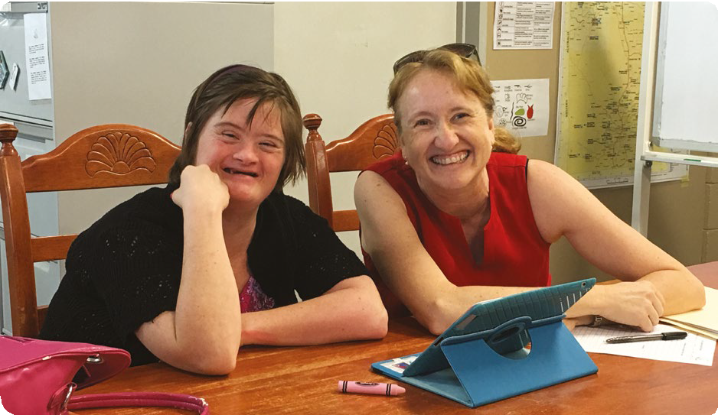The success of Sally’s transition into supported accommodation began with the introduction of the visual calendar. Progress developed through the use of icons that Sally became familiar with. This developed into words for reading, especially the names of her fellow housemates and the support team who worked in her home. Then, a breakthrough: Sally started clearly using people’s names to address them. This surprise development spurred them on to teach her even more and the iPad became the tool to interact further with Sally.
The NDIS planning commenced, assisted in part by Down Syndrome Association NT who introduced Sally to the Computer Aided Learning (CAL) program. Weekly CAL lessons with her teacher Lyndy created the backbone of her speech development through a range of apps currently used in schools. Sally took to technology quickly. Her
iPad held a range of educational apps and they built a visual library of the people, places and activities she was now experiencing. This approach was shared with her support workers and they delighted in experiencing Sally’s increasing vocabulary.
Sally’s NDIS plan also included signing classes to further develop her communication skills. She had basic signs from her primary school education but here she was exposed to activities that expanded her vocabulary and included regular practice in reading texts, writing, and number work–which she developed a love for. Whilst Sally had less
speech than the other class members, this did not stop her developing friendships and other students were in awe of her natural ability to copy signs. Expanding Sally’s education revealed a nature that absorbed all the things happening around her. She showed pride in singing along to familiar lyrics and naturally picking up signs to words that were obviously familiar to her through her lifelong church attendance.
One last piece of the learning journey was to consider alternate work experience for Sally who, whilst comfortable in routine skills associated with her disability employment workplace of seventeen years, had never experienced other work environments. Sally’s NDIS plan included six hours per week training at Walking In My Shoes (WIMS)–a retail social enterprise run by the Down Syndrome Association NT. Gentle entry into the shop environment coupled with structured tasks has given Sally a new enthusiasm for work, which includes sorting and presentation of shoes, writing price tags and cleaning stock.
So, now her life is busy. The daunting decisions of twelve months ago are long behind Sally and her family. Prompted by change but supported by a curriculum of educational activities, Sally has proved that it really is never too
late to learn.

Rachel Kroes is Executive Officer of Down Syndrome Association NT.

