Inclusive education: When research
evidence is not enough

By Dr Glenys Mann
When parents are making decisions about schooling for their sons and daughters with Down syndrome, particularly whether to choose regular (also known as mainstream or general) schooling or not, they may look to what research can tell them about the best education for their children–and rightly so. Having some understanding of the research in this area can boost a parent’s confidence in their choice of a regular school, provide a firm foundation for advocacy efforts, and make them feel better equipped for their role in the parent-professional partnership. To that end, this article provides a summary of some of the research into inclusive education for students with intellectual disability.
The research also tells us that having a child well included is not just a matter of knowing the evidence. The academic and community literature is full of stories of poorly implemented ‘inclusive education’, despite the research, and this is more likely for children with an intellectual disability who are still routinely directed to special schools. Therefore, this article also reflects on why relying on academic evidence is not enough when seeking inclusion in a regular school and outlines other information and skills that parents might use in order to pursue inclusive lives for their children.

The evidence for inclusive education

Academic benefits
Given the purpose of schools, the issue of academic learning for students with intellectual disability can be uppermost in parents’ minds when they consider enrolment options. In spite of a common belief that students with intellectual disability need separate, special schooling, studies have shown a connection between the time a student spends in general classrooms and academic achievement. One such study found a strong positive relationship between hours in a regular classroom and
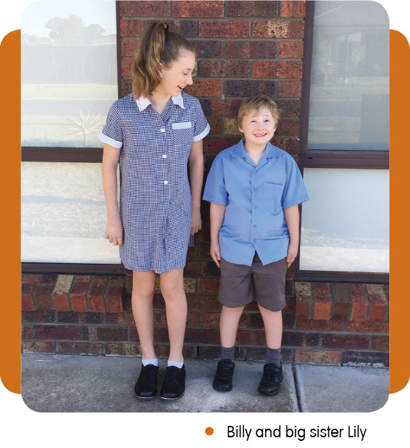achievement in mathematics and reading. Another found that regular schooling had a positive effect on academic learning, particularly on reading skills. A case study by McLeskey, Waldron, and Redd (2014) highlighted that schools could be both inclusive and effective academically. All of these examples add to the investigation commissioned in 2008 through which Jackson found no review ‘comparing segregation and inclusion that came out in favour of segregation in over forty years of research’ (p.4). Even for students considered to have significant intellectual disabilities, regular classrooms are considered to provide benefits that are hard to replicate in segregated settings, for example, teacher expertise in academic content, potent learning materials, and natural peer support.

Social benefits
Parents of children with Down syndrome are interested in their child’s social life as well as their academic learning.
Parents want authentic relationships for their children and worry about regular schooling in this regard. These concerns are understandable; physical presence alone does not automatically lead to positive social outcomes in regular classrooms. Inclusion is about more than mere physical presence however, and there is evidence to suggest that inclusive education can benefit children socially as well as academically. Over ten years ago, research found gains in independence and social skills when children were educated in the regular school rather than in separate settings. More recently, it was concluded that an effective strategy for achieving true social inclusion is ‘regular contact in integrated environments [such as regular schools], with opportunities for meaningful interaction’. Similarly, Cologon (2013) linked inclusive education with increased social interaction, and Georgiadi, Kalyva, Kourkoutas, and Tsakiris (2012) found that while contact between students with disabilities and those without was an important factor in positive attitudes towards classmates with disability, it was not contact alone that was significant, but the inclusive setting itself. Furthermore, the social benefits of inclusive education have been found for students considered to have severe disabilities in the secondary school setting. For example, Carter and colleagues (2016) found that students supported by classmates (with formalised support arrangements) experienced both academic and social benefits, including gaining new friends.

Benefits for the long term
Our schooling experiences are a foundation for the rest of our lives. It is interesting, then, to see what the research has to say about the impact of inclusive education on life after school. A number of links have been found between the adult lives of people with intellectual disability and school setting. For example, a 2009 study found that inclusion in general education predicted improved outcomes in post-school education, employment, and independent living and this finding was confirmed recently. Similarly, segregated schooling has been linked with exclusion from the labour market; school exclusion has been associated with long-term poorer health outcomes, and inclusive education has been found to have a positive impact on students with significant 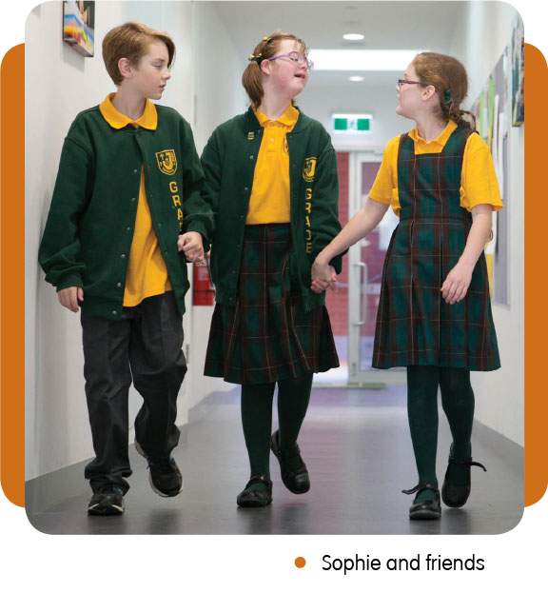disabilities after school (e.g., paid community employment). Additionally, Lombardi and her colleagues (2013) found an association between general classrooms and an increased likelihood of participation in post-school education. Furthermore, links between inclusion in general classes and increased participation in social networks as young adults suggest a connection between inclusive education and social inclusion which is difficult to ignore.

Benefits for others
It is not only the student with intellectual disability who benefits from school inclusion. Children who don’t have a disability also benefit from inclusive education in a number of ways. These include a positive impact on academic achievement and flexible, individualised teaching and learning strategies that benefit all students, for example, Universal Design for Learning (UDL) and differentiated instruction. Teachers also benefit professionally from the skills they acquire in order to teach diverse students, for example, skills with using accommodation and modification strategies. Evidence of these skills is now mandatory in a teacher’s professional portfolio in order to meet the National Teaching Standards in Australia.

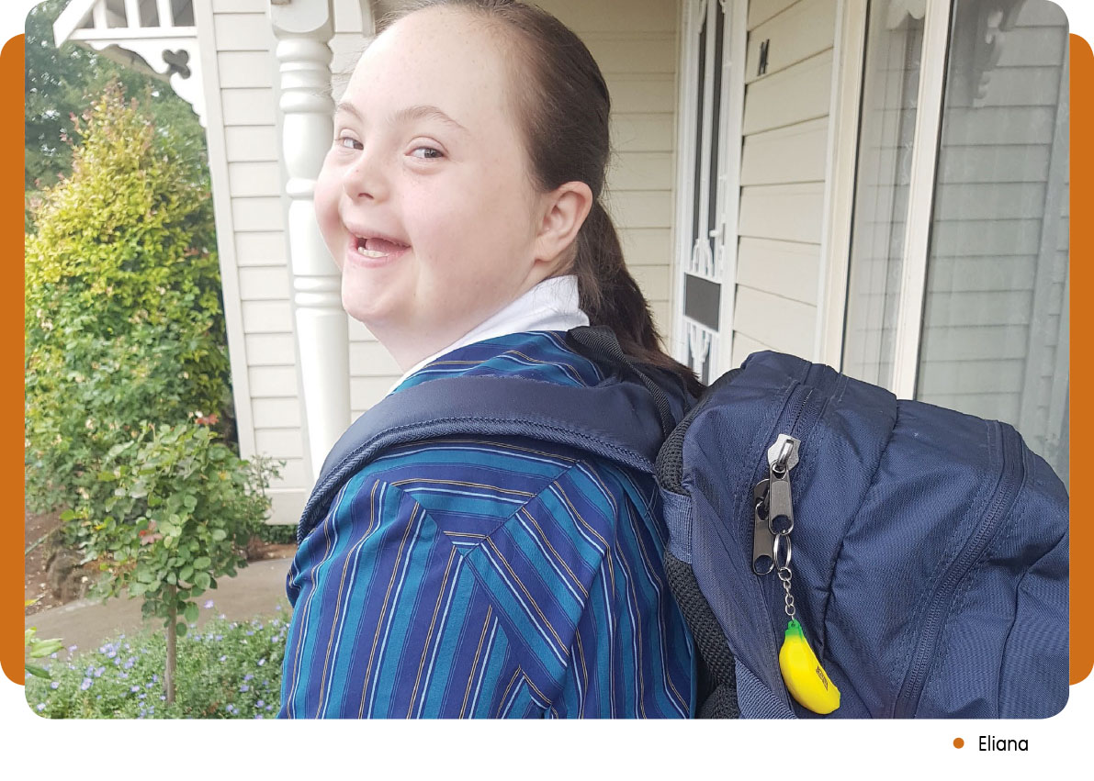

When evidence is not enough
Although evidence for the benefits of inclusive education is strong (and becoming even stronger), knowing and sharing the research is usually not enough to ensure that children are welcome, wanted and valued in the school their parents choose. How could this be so? In 2008, McDevitt and Ormrod wrote about why conceptual change is so hard for prospective teachers. Although they were not writing in the context of inclusive education, I find the points they make very relevant to why teachers–or any of us– might not embrace the research evidence or might struggle with the mental disturbance associated with becoming more inclusive.
I have considered their points in relation to inclusive reform, and have outlined my thoughts below:
- Prior knowledge and beliefs are persistent. It is likely that teachers draw on what they currently know and believe to interpret inclusive language and concepts, thereby inhibiting the fundamental changes in thinking that are required for inclusion.
- Teachers can also fall victim to drawing on their own experiences to draw incorrect conclusions about inclusion.
- Teachers may take evidence on board in a ‘rote’ fashion, and not realise that the new information contradicts what they already believe. They may be able to cite evidence correctly, but continue to apply original beliefs and understandings when interpreting inclusive education in their classrooms.
- Teachers may–consciously or otherwise–‘look for information that supports existing beliefs and to ignore or discredit any contradictory evidence’. As a consequence, they will hold to existing views rather than considering other possibly conflicting ideas.
- The existing teaching culture in schools will be a strong force and may be accepted without question as an obvious, indisputable truth.
- Teachers face many competing pressures. Under stress or faced with limited time and resources, teachers may revert to old habits and the ‘evidence’ may be overridden.
- Teachers may have an anti-research bias and be suspicious of academic research. The evidence for inclusive education may be discounted in favour of a teacher’s own intuitive judgement.
It is also true that academic evidence can be difficult for parents to find, complex to understand, and contradictory.

Other information and skills that parents can draw on
If the research is not enough to secure enrolment in a regular school with an inclusive experience, what more do parents need? I suggest that research evidence, as important as it is, is the icing on the cake. Inclusive education is not just a matter of science. It is a fundamental human right, a means to avoid the damage done by segregation and congregation, a pathway to a better life than has historically been available to people with disability, and an increasingly accepted societal expectation.

Advice for parents
To make inclusive education a reality for your child, it will be helpful to consider the following:
- Knowledge of legislation and policy. Our education systems fall under the jurisdiction of the UN Convention on the Rights of Persons with a Disability, Article 24, which mandates that children must not be ‘excluded from the general education system on the basis of disability’. Nationally, our students have anti-discrimination legislation, including education standards, to protect them, and a curriculum which recognises and is responsive to diversity. Teachers have national professional teaching standards which include knowledge of ‘strategies to support full participation of students with disability’. Familiarity with these overarching requirements, and knowledge of relevant education policies, will give you confidence that your preference for inclusion is not just a parent’s whim, and courage to have high expectations of your child’s school.
- Advocacy skills. While conflict may not be your cup of tea, it is likely–should you wish to pursue inclusive education–that at some point you will have to confront authority. To do this well, you will need to 1) claim your own natural authority as a parent, 2) understand and accept the critical importance of advocacy in your child’s life, and 3) hone your own advocacy skills.
- Relationship skills. You cannot enact inclusive education on your own, no matter how deep your beliefs or extensive your efforts. For inclusive education to work, you need teachers. And to work well with teachers, you will need to know how to build good relationships. A critical aspect of good relationships is learning how to listen. Speaking fiercely–but without criticism and blame–about what our children need is difficult enough; listening fiercely is likely to be harder still.
- Networks. Pursuing inclusive education can be difficult. Networking with other like-minded people offers many benefits including inspiration, motivation, and support when things are not going well. Join inclusive education collectives and seek out other parents who are following the same path. Look for stories and shared, lived experiences of inclusion not just academic research. All personal experience is valid, and you may find it as helpful, if not more so, than scientific evidence.
Dr Glenys Mann is a sessional academic working in the area of inclusive education and has a background in primary school teaching. She has previously been president, secretary, and an education consultant at DSAQ. Glenys also has a son with Down syndrome who is 24 years old.

References
- Australian Institute for Teaching and School Leadership. (2011). Australian professional standards for teachers. Victoria: Ministerial Council for Education, Early Childhood Development and Youth Affairs.
- Biklen, D. (2015). Why the pursuit of inclusive education cannot be left to science: Lessons from the work of Burton Blatt. In P. Jones, & S. Danforth (Eds.), Foundations of Inclusive Education Research (pp. 187-204). Emerald Group Publishing Limited.
- Carter, E. W., Asmus, J., Moss, C. K., Biggs, E. E., Bolt, D. M., Born, T. L., . . . Weir, K. (2016). Randomized Evaluation of Peer Support Arrangements to Support the Inclusion of High School Students With Severe Disabilities. Exceptional Children, 82(2), 209-233. doi:10.1177/0014402915598780
- Cologon, K. (2013). Inclusion in education: towards equality for students with disability. Retrieved from Australia:
- Cosier, M., Causton-Theoharis, J., & Theoharis, G. (2013). Does access matter? Time in general education and achievement for students with disabilities. Remedial and Special Education, 34(6), 323-332.
- De Graaf, G., Van Hove, G., & Haveman, M. (2013). More academics in regular schools? The effect of regular versus special school placement on academic skills in Dutch primary school students with Down syndrome. Journal of Intellectual Disability Research, 57(1), 21-38.
- Emerson, E. (2013). Commentary: Childhood exposure to environmental adversity and the well‐being of people with intellectual disabilities. Journal of Intellectual Disability Research, 57(7), 589-600.
- Fisher, M., & Meyer, L. H. (2002). Development and social competence after two years for students enrolled in inclusive and self-contained educational programs. Research and Practice for Persons with Severe Disabilities, 27(3), 165-174. doi:10.2511/rpsd.27.3.165
- Forlin, C., Chambers, D., Loreman, T., Deppeler, J., & Sharma, U. (2013). Inclusive education for students with disability: A review of the best evidence in relation to theory and practice. Retrieved from Canberra:
- Georgiadi, M., Kalyva, E., Kourkoutas, E., & Tsakiris, V. (2012). Young children's attitudes toward peers with intellectual disabilities: Effect of the type of school. Journal of Applied Research in Intellectual Disabilities, 25(6), 531-541. doi:10.1111/j.1468-3148.2012.00699.x
- Jackson, R. (2008). Inclusion or segregation for children with an intellectual impairment: What does the research say? Retrieved from Brisbane: http://www.family-advocacy.com/resources/inclusion-or-segregation-for-children-with-an-intellectual-impairment-what-does-the-research-say/
- Kleinert, H., Towles-Reeves, E., Quenemoen, R., Thurlow, M., Fluegge, L., Weseman, L., & Kerbel, A. (2015). Where Students With the Most Significant Cognitive Disabilities Are Taught: Implications for General Curriculum Access. Exceptional Children, 81(3), 312-328. doi:10.1177/0014402914563697
- Kvalsund, R., & Bele, I. V. (2010). Students with special educational needs—Social inclusion or marginalisation? Factors of risk and resilience in the transition between school and early adult life. Scandinavian Journal of Educational Research, 54(1), 15-35.
- Lalvani, P. (2013). Land of misfit toys: Mothers’ perceptions of educational environments for their children with Down syndrome. International Journal of Inclusive Education, 17(5), 435-448. doi:10.1080/13603116.2012.683047
- Lombardi, A., Doren, B., Gau, J. M., & Lindstrom, L. E. (2013). The influence of instructional settings in reading and math on postsecondary participation. Journal of Disability Policy Studies, 24(3), 170-180.
- Mazzotti, V. L., Rowe, D. A., Sinclair, J., Poppen, M., Woods, W. E., & Shearer, M. L. (2016). Predictors of post-school success: A systematic review of NLTS2 secondary analyses. Career Development and Transition for Exceptional Individuals, 39(4), 196-215. doi:10.1177/2165143415588047
- McDevitt, T. M., & Ormrod, J. E. (2008). Fostering conceptual change about child development in prospective teachers and other college students. Child Development Perspectives, 2(2), 85-91.
- McLeskey, J., Waldron, N. L., & Redd, L. (2014). A case study of a highly effective, inclusive elementary school. The Journal of Special Education, 48(1), 59-70.
- National Council on Intellectual Disability. (2013). The right of persons with disabilities to an inclusive education without discrimination: Submission to the office of the United Nations High Commissioner for Human Rights. Retrieved from ACT Australia:
- Novak Amado, A., Stancliffe, R. J., McCarron, M., & McCallion, P. (2013). Social Inclusion and Community Participation of Individuals with Intellectual/Developmental Disabilities. Intellectual and Developmental Disabilities, 51(5), 360-375. doi:doi:10.1352/1934-9556-51.5.360
- Pfahl, L., & Powell, J. J. W. (2011). Legitimating school segregation: The special education profession and the discourse of learning disability in Germany. Disability & Society, 26(4), 449-462. doi:10.1080/09687599.2011.567796
- Rossetti, Z. (2014). Peer Interactions and Friendship Opportunities Between Elementary Students With and Without Autism or Developmental Disability. Inclusion, 2(4), 301-315.
- Ryndak, D. L., Alper, S., Hughes, C., & McDonnell, J. (2012). Documenting the impact of educational contexts on long-term outcomes for students with significant disabilities. Education and Training in Autism and Developmental Disabilities, 47(2), 127-138. Retrieved from jstor website - offers 3 free articles; I joind up
- Siperstein, G. N., Norins, J., & Mohler, A. (2007). Social acceptance and attitude change. In J. W. Jacobson, J. A. Mulick, & J. Rojahn (Eds.), Handbook of intellectual and developmental disabilities (pp. 133-154). New York: Springer.
- Szumski, G., Smogorzewska, J., & Karwowski, M. (2017). Academic achievement of students without special educational needs in inclusive classrooms: A meta-analysis. Educational Research Review.
- Test, D., Mazzotti, V., L., Mustian, A., L., Fowler, C., H. , Larry, K., & Kohler, P. (2009). Evidence-based secondary transition predictors for improving postschool outcomes for students with disabilities. Career Development for Exceptional Individuals, 32(3), 160-181. doi:10.1177/0885728809346960

There is certainly research regarding inclusive education for students with Down syndrome specifically, but I have chosen to look at intellectual disability generally here because 1) focusing too strongly on specific disability diagnoses is not helpful when thinking about inclusion and may, even unconsciously, promote the idea that inclusion is good for some students but not others 2) it seems to be the challenges associated with intellectual ability that most threatens inclusive experiences, so research that raises questions about this thinking is important for all vulnerable students.
Cosier, Causton-Theoharis, & Theoharis, 2013
De Graaf, Van Hove, & Haveman, 2013
Kleinert et al., 2015
Siperstein, Norins, & Mohler, 2007
Jackson, 2008; Lalvani, 2013; National Council on Intellectual Disability, 2013; Rossetti, 2014
Fisher & Meyer, 2002
Novak Amado, Stancliffe, McCarron, & McCallion, 2013, p. 363
Test et al. (2009)
Mazotti et al. (2016)
Pfahl and Powell (2011)
Emerson (2013)
Ryndak, Alper, Hughes, & McDonnell (2012)
Kvalsund & Bele, 2010
Szumski, Smogorzewska, & Karwowski, 2017
Forlin, Chambers, Loreman, Deppeler, & Sharma, 2013
Australian Institute for Teaching and School Leadership, 2011
http://www.margaretwheatley.com/articles/pleasedisturb.html
McDevitt & Ormrod, p. 87
Biklen, 2015
http://www.un.org/disabilities/documents/convention/convoptprot-e.pdf
https://docs.education.gov.au/system/files/doc/other/disability_standards_for_education_2005_plus_guidance_notes.pdf
https://www.aitsl.edu.au/docs/default-source/apst-resources/australian_professional_standard_for_teachers_final.pdf
http://cru.org.au/wp-content/uploads/2014/04/4.-The-Natural-Authority-of-Families-MKendrick-CT45.pdf
https://www.cheshire.ie/userfiles/file/infobank/servicedesign/Advocacy%20and%20Authority.pdf
http://cru.org.au/wp-content/uploads/2017/02/QPPD-I-choose-Inclusion-Booklet.pdf

