Making change: A brief look at the work

DSA does to effect systemic change

By Dr Ellen Skladzien

The lives of people with Down syndrome have changed dramatically over the last 30 years. In the 1980s people with Down syndrome had life expectancies of only 25 years and were often excluded systematically from their communities by learning in special schools, working in sheltered workshops, and living in group homes or institutions. There is still a long way to go, but life has changed for people with Down syndrome. Today people are living longer, healthier lives and experiencing greater inclusion in our communities. NDIS has provided yet another opportunity to push boundaries and provide new opportunities for people with a disability.
These changes haven’t happened overnight. They are the result of people with disabilities, families and organisations working tirelessly to change community attitudes and public policies.
Some changes happen gradually and quietly, such as improved access to medical care and early intervention, and others are the result of big policy changes that have long term impacts, such as the implementation of the NDIS or the UN Convention on the Rights of People with a Disability.
Down Syndrome Australia is the policy and systemic advocacy arm of the Down syndrome federation. Our purpose is to influence social and policy change, and provide a national profile and voice for people with Down syndrome in Australia.
People often wonder what does that really mean? What do we do to achieve change? What does systemic advocacy look like in a tangible way? For each issue, there are usually multiple strategies and approaches. If we take prenatal screening for Down syndrome as an example, we can identify the issues easily. We know that women are not properly informed about screening before it happens, and the information they are provided after screening is often out-dated and inappropriate. Some women report feeling pressured about decisions on termination with doctors telling them that a child with intellectual disability will have a lifetime of suffering.
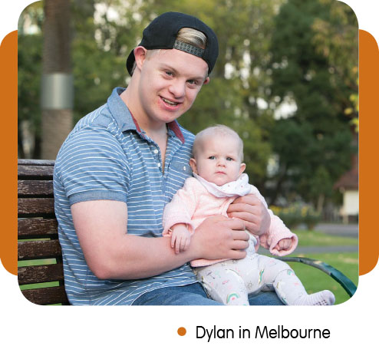

What do we need to create change?
The most important tools for creating change are gathering evidence and personal stories or experiences. Part of this is finding relevant research, but it is also about talking to our members. Last year we did the first national survey of our members and we were able to get some great information about people’s experiences with prenatal screening and support during pregnancy. We also gathered stories about the impact that doctors have on families when they provide information after a screening test.
We also now have the fabulous input of the Down Syndrome Advisory Network. This network, made up of people with Down Syndrome across Australia, is providing input and feedback into all of the policy work that we do. This ensures that our advocacy is guided by the views of people with Down syndrome.
Another key tool is developing relationships with government departments, key ministers and people of influence. This takes time and careful consideration on how to have influence without disrupting those relationships.

Ways we make change happen
With prenatal screening, families have told us that they need balanced information when they are trying to make decisions about screening or how to respond to a result. As a result, we developed a factsheet about prenatal screening and Down syndrome. This factsheet continues to be one of the most commonly downloaded resources from our website. We also worked with Roche, one of the biggest suppliers of the prenatal screening test in Australia, to develop factsheets for GPs to give to families providing balanced information on Down syndrome.
At the same time, we work to change things in terms of government policy. DSA provided a submission to the development of new Department of Health guidelines for antenatal care. In it we outlined suggestions and advice to change the guidelines to ensure that issues around prenatal screening and support were dealt with appropriately. We have had feedback that our submission has led to changes in the guidelines, although we are still waiting to see the final document.
We have also been working to influence the outcome of the Federal Government’s current consideration to publicly fund prenatal screening. We provided an extensive submission to the Medical Services Advisory Committee who will provide a recommendation to the Minister of Health regarding whether these tests should be publicly funded. At the same time, we have been meeting with relevant government ministers and policy makers to share our concerns. The data and experiences we have gathered from our members has assisted in the strength of that argument.
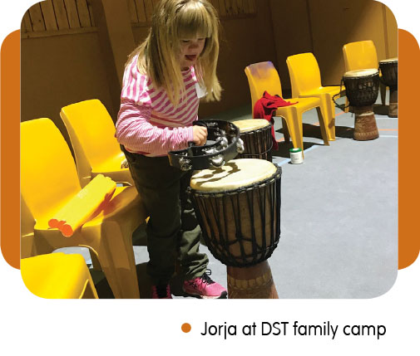
As part of this advocacy, we have made a strong argument that screening without appropriate supports and information in place is unethical, and that a program of education is absolutely necessary if non-invasive prenatal screening is to become publicly funded. We have provided the government with a funding submission to create a program which mirrors the UK program Tell It Right®
Start It Right. This would be an education program for GPs and midwives on how to provide information to families about Down syndrome and to help them understand what life is like for a person with Down syndrome in the modern world.
It is important to engage with the media on these issues to provide information and advice on stories around prenatal screening. We do this carefully as the media are often just interested in a headline and not so interested in the nuances of the story.

Changing attitudes
Equally important is the work we do trying to change community attitudes. The World Down Syndrome Day countdown which ran during March provided stories about how people with Down syndrome are involved in their communities. Last year, we had a number of emails from people–who had no personal experience with people with an intellectual disability–tell us that the campaign had changed their opinion about Down syndrome and how they would respond to people they met in the community. Changing community attitudes and expectations is an important part of ensuring people have more support after a prenatal diagnosis of Down syndrome.

A national voice for voice for Down
syndrome issues
Hopefully this gives you a snapshot of some of the things Down Syndrome Australia does to try to create change. Prenatal screening is just one of the many issues which we are advocating on but the approach is similar for a lot of the work we do. Policy change and shifts in community attitudes take time and success is not always guaranteed but it is important to have a united and national voice representing people with Down syndrome at this level. You can help by engaging Down Syndrome Australia to assist with the issues that are important to you and your family and stay in touch with the work we are doing. We are passionate and committed to working towards a society where people with Down syndrome are included as equal members of our community.
Dr Ellen Skladzien is the CEO of Down Syndrome Australia.

