NDIS: From idea to policy
and beyond

By Kirsten Deane
A couple of years ago I was lucky enough to be at the opening of the National Disability Insurance Scheme (NDIS) offices in Penrith, in western Sydney. At the opening was another mum who I had known for a while. We were chatting about how we felt to see yet another office open–one step closer to finally seeing the NDIS dream become a reality.
She remembered that, a few years before, she had written an article about the NDIS for a magazine. She confessed that, even though she was a passionate supporter of the idea and had been an active advocate and campaigner from the beginning, she secretly wondered if the NDIS would ever see the light of day. Given the historic treatment of Australians with disability, she wondered if the community would ever get behind such a big reform. In her heart-of-hearts, she despaired that things would never change.
And yet, there we both were as the pollies cut the ribbon. The NDIS had gone from good idea to reality–and in a relatively short space of time. We both had a bit of a cry, gave each other a hug and–most importantly–resolved to keep going.
I think it is important to remember moments like those. We live in a time where people are very cynical about politics and public affairs. Experienced and well respected political commentators and analysts have even gone so far as to suggest that the age of reform is over in Australia. They argue that the public, and therefore politicians, no longer have the stomach for big changes. That everyone is too self-interested and self-absorbed.
Sometimes it’s hard to argue against that–particularly given recent events in Canberra.
But the National Disability Insurance Scheme is the reform that proves them wrong, and the Every Australian Counts is the campaign that proves ordinary people can still use their voice to create big changes.
While the idea behind the NDIS has been around for a long time, the campaign to get it introduced really only began in 2009. Four years later, on July 1 2013, the National Disability Insurance Agency opened its doors in four trial sites around the country.
For a reform the size and complexity of the NDIS, to move from go to whoa in four years is pretty fast. For governments that often move at a glacial pace, it was positively supersonic.
And while it all seems like an inevitability now, it did not feel like that back in 2009. There were so many things standing in the way of the NDIS. Issues affecting people with disability were really low on the political totem pole–in fact they were so low they were underground. Public understanding of the issues was zero, and interest in fixing them even less. In this situation, many groups pay for fancy-pants lobbyists to walk the halls of Parliament House to push for change–but we didn’t have any money for that. And there certainly wasn’t any money for advertising to create ‘awareness’.
The very people who most needed help–people with disability and their families–were so stretched just surviving from day-to-day it was hard to find the time and energy for anything else. And to make matters worse, the disability sector itself was fractured and split and routinely descended into squabbles.
The NDIS was also big, complicated and expensive. It was hard to explain and even harder to understand.
In short–it was always going to be a tough fight.
But we had one secret weapon–people power. Thousands of passionate people with disability and their families desperate to finally see change.
Ultimately, Every Australian Counts was successful because it brought people together. It was old-fashioned grass roots organising at its very best. All around the country, thousands of volunteers held morning teas; letterboxed their street; pestered their family, friends and neighbours; talked to everyone and anyone about why the NDIS was so important.

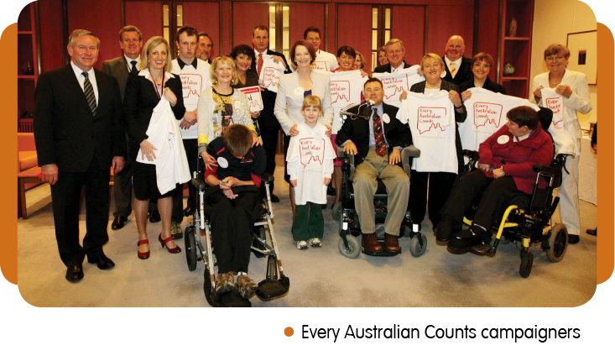
It was people with disability and their families telling their stories–of what their life was like now and what it could be like under the NDIS–that changed the hearts and minds of both the Australian public and our elected representatives.
It’s a nice story but why does it matter now? Because the job’s not done yet.
We are almost five years into the roll out of the NDIS. It would be something of an understatement to say things have not gone smoothly. While no one thought it would be easy, it has undoubtedly been harder than it has needed to be.
Kirsten Deane is currently the Campaign Director of Every Australian Counts, the campaign for the NDIS. She also serves as Executive Director of the National Disability and Carer Alliance. Kirsten is the former Director in the Information Linkages and Capacity Building (ILC) team at the NDIA and National Manager of Communications and Engagement at AFDO. She has been a long-term board member of both DSA and DSV.
The planning process is complex and confusing. There are multiple and often inexplicable delays. Communication out of the NDIS is often indecipherable. Planners and Local Area Coordinators don’t seem to have appropriate training or support for their important role. Some people are falling through the cracks. Others feel they are worse off than before. Important programs are disappearing as funding gets tipped into the NDIS. Advocacy is shrinking. There are not enough services. Providers are having trouble getting paid. And let’s not even get started on the IT.
This is not the scheme we fought for.
It will be, but we are going to have to fight to make sure that happens.
NDIA has work underway to improve the participant experience through a new participant pathway. For more information please go to www.ndis.gov.au/participants/pathway-experience/participant
Every Australian Counts has just launched a new campaign called Fund it and Fix it. We want to use this campaign to get the NDIS back on track. To make sure it delivers the transformation we all want.
Just in case any pollies are listening we won’t reveal all our plans but we will be back to what we did best–telling stories about what the problems are and how we want them fixed. And fixed fast.
We know that sounds exhausting. But we have seen what extraordinary things can happen when we work together. We have moved the mountain once–we can do it again.

