Supporting community inclusion -
New DSA resources

By Kylie Preston
Community inclusion is often talked about but what does it really mean and how can it become a reality?
For the last few months, Down Syndrome Australia (DSA) has been working with people with Down syndrome and their families to develop resources on community inclusion. These resources are designed to help community groups and others to support people to be included and participate in everyday activities.
People with Down syndrome often face barriers to participating in activities in their community. A national survey conducted by DSA in 2017 revealed that some of the barriers people experience include the availability of accessible activities, the availability of support, and transport. While many people felt that their community was supportive and inclusive, 30% indicated that they, or the person with Down syndrome, have experienced stigma or discrimination in the community because of their disability.
People with Down syndrome want to take part in the community for exactly the same reasons as their peers without a disability – for social contact, fun, fitness, to have a job, to utilise their skills and to increase their confidence and self-esteem. Being inclusive is about finding, offering and supporting opportunities for people of all ages, abilities and backgrounds, to participate, learn, contribute, and to belong. In practice, this may involve community organisations identifying the needs of a person with Down syndrome who wants to be included and coming up with strategies and ideas of how to make that happen. When community groups work together alongside the person with Down syndrome and their families, meaningful inclusion can happen – which benefits everyone.
DSA is often contacted by community groups, employers and sporting groups asking for information about Down syndrome or about how to include people with Down syndrome in their organisations. We saw an opportunity to help support inclusion by developing some easily accessible information for community groups and people with Down syndrome and their families.
Down Syndrome Australia, with funding from the National Disability Insurance Agency (NDIA), has developed a Community Inclusion Toolkit to give 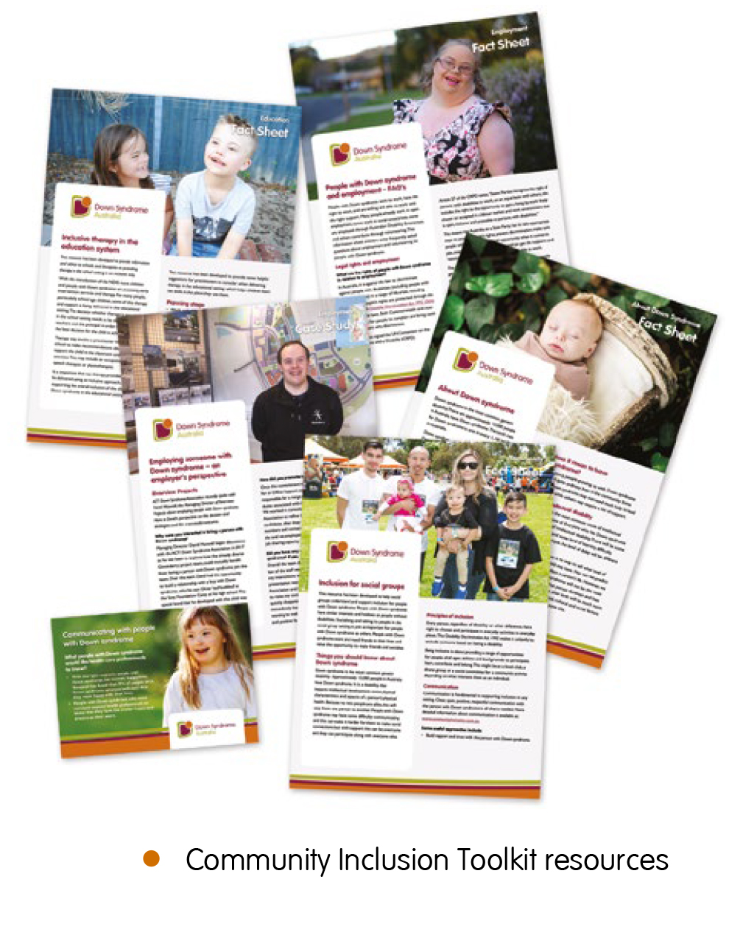people practical information about how to support inclusion. The toolkit will help people understand why inclusion is important and how to make it happen. This includes tips and advice on the changes that can be made, templates for providing information about the support needed by the person with Down syndrome, as well as other tools. The toolkit focuses on education, employment, health settings, and community and sporting groups.
We spoke to people with Down syndrome and their families across Australia about their experiences and what could be done to help them get more involved in their community. We took this information and used it to create videos, fact sheets, information sheets, PowerPoint presentations and case studies. Some of these resources are for people with Down syndrome and their families; others are for community group leaders, health professionals, employers, teachers or others.
The fact sheets and information sheets are easy to download from the website and share. Community groups or sporting groups can distribute the information to the people who work directly with someone with Down syndrome, or maybe print and pin up in the staff room for example. Families may want to use this information to give to community groups that they are involved with or are trying to access. There are also worksheets to help people with Down syndrome and their families articulate the specific needs they have before they start looking a job, finding a health professional, or joining a sporting club.
The toolkits include case studies to help show what can be achieved when people with Down syndrome are supported to be included in their communities. One example of inclusion in education is highlighted in a case study in the toolkit called ‘Inclusion in practice in a mainstream school – Ryan’s experience’. This case study discusses the approach Ryan’s school took to help him develop both academically and socially in the school setting. The school has embraced inclusion as a school community responsibility and focused their activities, not just on working with Ryan, but building understanding of difference with all students.
The toolkit includes videos of people with Down syndrome and family members talking about their advice for employers, educators, doctors and community group leaders. These videos also touch on the challenges and barriers that some people experience in the community.
Another part of the toolkit includes information to help families develop a good relationship with health professionals. This includes a postcard which provides communication tips for health professionals when talking with patients who have Down syndrome. In the health resource, there is also a useful ‘About me’ sheet that people with Down syndrome can complete and share so that their health professionals can understand a bit more about their patient’s needs and how best to support them in an appointment.
The toolkit also links to resources that other organisations have developed. For example, in the education section, there is a resource from Imagine More that provides tips from families about inclusive education from their experiences.
Down Syndrome Australia would like to acknowledge the NDIA for the funding to support this work. Promoting inclusion in the community has never been so important and we ask that families, friends, people with Down syndrome, employers, instructors and teachers promote and use these resources to make inclusion a reality for people with Down syndrome. So, share them widely on social media, in your sporting groups, your workplaces, schools and medical setting.

Information for Life resources
Major life transitions, like adolescence or moving in to your own home, can be regular sources of upheaval and stress for people with Down syndrome and their families. However, being prepared in advance and having access to quality information can make these transitions much smoother. To address this, Down Syndrome Australia has also developed a suite of new resources called Information for Life that takes a comprehensive look at some of the major transitions a person with Down syndrome may face.
The Information for Life resources available are:
Guide for expectant parents
- Guide for new parents (FAQ)
- Guide for new parents
- Early years
- Adolescence
- Living independently – Easy Read
- Living independently – Plain English
- Employee’s Guide – Easy Read
- Employee’s Guide – Plain English
- Employer’s Guide
- Ageing.

These guides are available for download in the new Resources section of the website: www.downsyndrome.org.au/resources or from your local Down syndrome state and territory organisation. Down Syndrome Australia is also planning to add to these resources over the coming months to ensure the relevant content is available in Easy Read format.
Kylie Preston is National ILC Project Manager for Down Syndrome Australia

