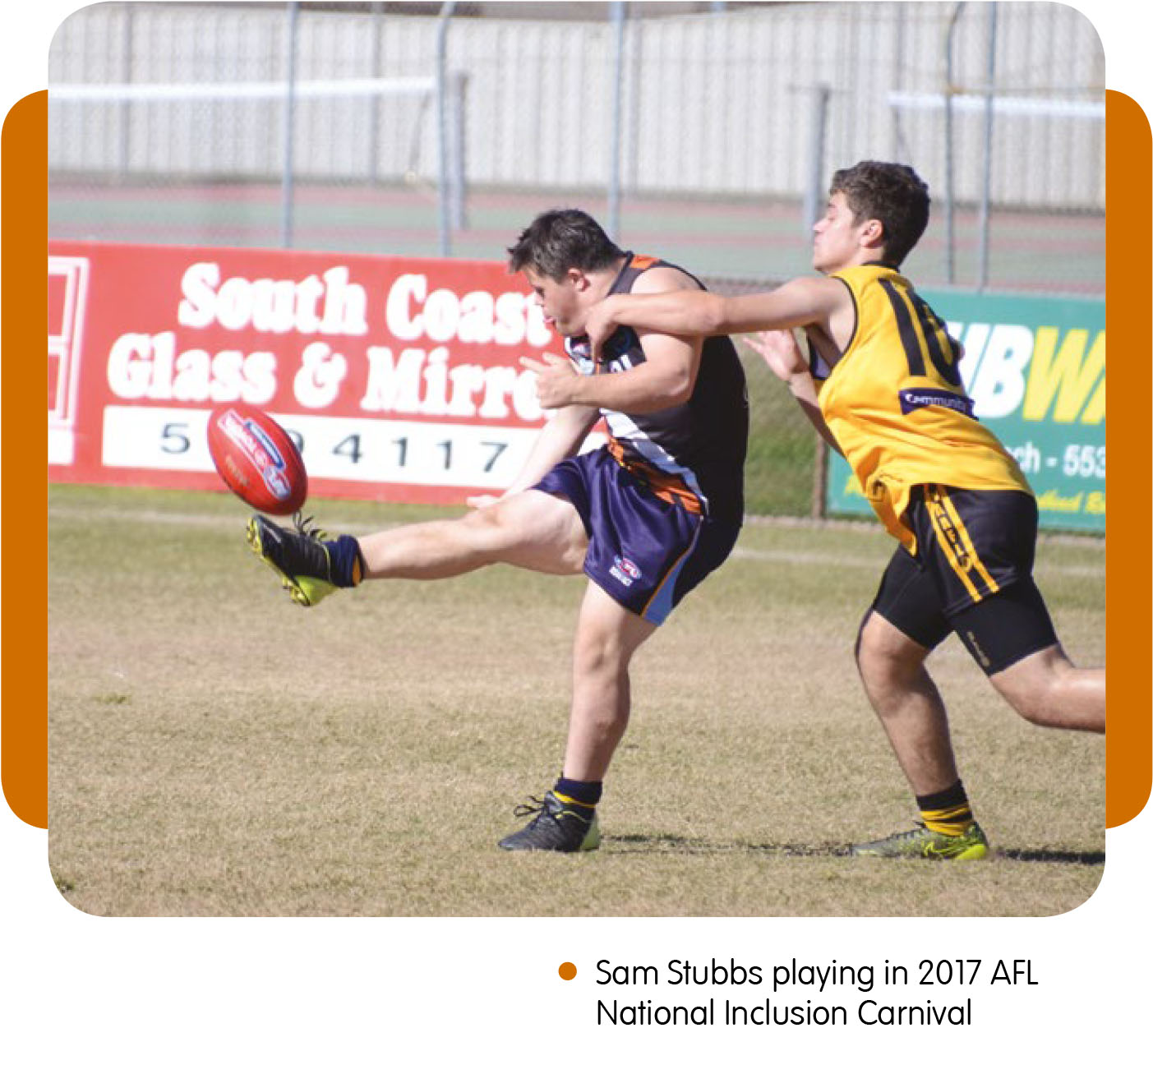
Social inclusion using sport as the medium

By Michael Thomson
Sport Inclusion Australia, formerly AUSRAPID, was founded in 1986 by Marie Little OAM to assist the inclusion of people with an intellectual disability into the mainstream community using sport as the medium. Together with its state member organisations, Sport Inclusion Australia has worked with national and state sporting organisations for over 30 years to assist them to be inclusive and provide sporting opportunities to all Australians. ‘Sport should be reflective of the entire Australian population,’ says Sport Inclusion Australia CEO Robyn Smith, who has worked in the inclusion sector for over 25 years.
Sport Inclusion Australia is a member organisation of the International Federation for Athletes with Intellectual Disabilities (INAS), Sports Union for athletes with Down Syndrome (SU-DS) and a founding member of the Australian Paralympic Committee (APC).
While their focus is on intellectual disability the principles of person-first and social inclusion are relevant for all cultural and diverse groups wanting to participate in sport. ‘Community inclusion through sport’ is Sport Inclusion Australia’s mantra.
‘Through being welcomed into community sporting clubs, athletes not only have the opportunity to participate and socialise like every other club member, but the benefits from sport have a more profound effect. Sport provides positive life skills, self-esteem, acceptance and a shared passion which allows athletes with a disability to flourish and grow, and – more importantly for the wider community – breaks down barriers,’ said Smith.
Through its work with School Sport Australia and its member organisations, national and state sports organisations, the Australian Paralympic Committee and its international affiliations, athletes with an intellectual disability now have pathway options from grass roots through to an international level.

While athletes with Down syndrome fit within the intellectual disability classification and are able to compete in mainstream sport alongside other athletes, it is clear that they cannot compete on a level playing field within the existing intellectual disability classification, as people with Down syndrome usually have some level of physical disability as well, such as low muscle tone. This is something which INAS and Sport Inclusion Australia have acknowledged with the development of two new classifications.
‘For the past four years, INAS has conducted research into extending the classification groups within INAS to incorporate and offer competition to athletes with an intellectual disability and an additional physical condition (II2) and high functioning autism (II3). In April 2017, it was announced that it will introduce two new classifications on a trial basis. In the initial stages the II2 classification has included athletes with Down syndrome,’ Smith said.
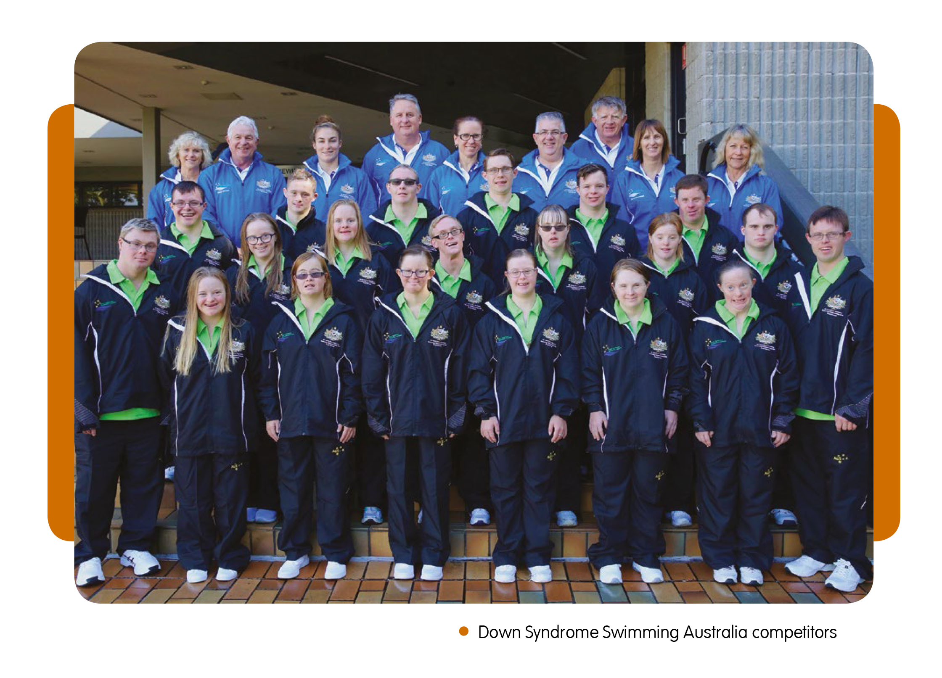

The 2017 INAS World Table Tennis Championships was the first event to include the new classification groups, followed closely by 2017 INAS Swimming Championships in Mexico. Both events were well supported by athletes from across the world.
2019 will see the largest sporting event for elite athletes with an intellectual disability in the world – the INAS Global Games held in Brisbane. The INAS Global Games will bring together over 1000 elite athletes competing in nine sports (athletics, basketball, cycling, futsal, rowing swimming, table tennis, Taekwondo (Poomsae), and tennis) played at sporting arenas within the city of Brisbane. Athletics, swimming and table tennis will include the new eligibility classification groups within their competition structure providing further opportunities for athletes with Down syndrome.
To further enhance the opportunities for athletes with Down syndrome, Sport Inclusion Australia joined the International Sports Union for athletes with Down Syndrome (SU-DS). SU-DS currently holds world and regional championships for athletes across a number of sports: swimming, athletics, table tennis, basketball and gymnastics.
Australia will be looking to field full teams in all of the sports and particularly in swimming, table tennis and athletics. Selection for these teams will be based on merit with athletes required to meet performance standards and be in the top three in the country for their event.
While the new groups may not be recognised at the local level yet, Sport Inclusion Australia is working with School Sport and other organisations to create awareness and implement a fair and equitable competition pathway.
One of the key tasks performed by Sport Inclusion Australia is athlete eligibility processing. To be classified as an athlete with an intellectual disability, athletes must meet the eligibility requirements of:
- IQ of 75 or below
- evidence of a disability before turning 18
- significant limitations in adaptive behaviour.
These eligibility requirements are established by the World Health Organisation and are the basis for classification and the elite athlete pathway.

Sport Inclusion Australia has supported Down Syndrome Swimming Australia (DSSA) since its inception in 2004 and this year DSSA will send a team of 20 athletes to Canada for the 9th World Down Syndrome Swimming Championships (held on July 20-26). In October, Queensland athlete Andre Rivett will represent Australia at the AIIDS Athletics World Championships in Portugal.
INAS has a wide range of sports including but not limited to athletics, tennis, table tennis, equestrian, swimming, Taekwondo (Poomsae), futsal, football, basketball, rowing, hockey, cricket, cycling and skiing.
Sport Inclusion Australia’s focus is not just on the elite pathways but importantly provides athletes with a choice – a range of inclusive sports, appropriate participation levels and, if appropriate, an elite pathway. The choices are growing which is fantastic and include not only the sports listed above but AFL, netball, indoor cricket, cricket, ten-pin bowling, softball, lawn bowls, rugby league and touch football to name a few.
Working with the AFL, VICSRAPID (Sport Inclusion Australia’s Victorian member organisation) assisted the formation of the FIDA football competition in Victoria. Today over 800 players with an intellectual disability are playing in the Victorian league and many more in other states including players with Down syndrome. Other success stories include the Australian Tennis Championships run by Tennis Australia and conducted alongside the Australian Open for over 20 years; the Ivor Burge Basketball Championships; the National Cricket Inclusion Championships and the Lord’s Taverners Indoor Cricket Shield are all events for players with an intellectual disability, run by the respective sport for over 20 years.
In a promotional video for the 2019 Global Games, Paul Staines, the father of an elite athlete says, ‘How does a person with an intellectual disability get to travel the world? Sport is somewhere that makes this possible!’
For more information contact:
www.sportinclusionaustralia.org.au

Contacts
Sport Inclusion Australia –
Michael Thomson
Michael.thomson@sportinclusionaustralia.org.au
03 57627494
Down Syndrome Swimming Australia –
Amanda Kerby
dssa.org@gmail.com
QLD - Life Stream Australia –
Chantel Lewis
clewis@lifestream.org.au
07 3394 4399
SA - Inclusive Sport SA –
Nathan Pepper
npepper@inclusivesportsa.com.au
08 8122 6732
WA - Inclusive Solutions –
Denver D’Cruz
denver.dcruz@inclusionsolutions.org.au
08 9201 8909
VIC/ACT - Sport Inclusion Australia –
Michael Thomson
Michael.thomson@sportinclusionaustralia.org.au
03 57627494
NSW – Sport 4 All –
Greg Brown
gregbrowns4a@gmail.com
0478 182 471
NT – Total Recreation –
Jason Bremner
jasonbremner@totalrecreation.org.au
08 8981 3686
TAS – New Horizons Club Inc –
Belinda Kitto
belinda@newhorizonsclub.org.au
03 6326 3344
Michael Thomson works as the Project Manager for Sports Inclusion Australia

