In conversation with
Prof. Sue Buckley OBE

By Sue O’Riley and Sheree O’Connor
We recently represented Down Syndrome Victoria at the World Down Syndrome Congress in Glasgow, where we had the chance to talk to Professor Sue Buckley OBE about inclusive education. Sue is Director of Science and Research at Down Syndrome Education (DSE) and Emeritus Professor of Developmental Disability, University of Portsmouth, UK and has an adult daughter who has Down syndrome.
Sue received an OBE from Queen Elizabeth II in 2004 for services to education and a National Down Syndrome Congress Education Award in 2016 ‘for improving the lives of children with Down syndrome by developing innovative research-based education techniques’.
Below is a snapshot of our conversation:
Sue O’Riley: Sue, what advice would you give to parents who are making a choice between mainstream and a special education environment?
Sue Buckley:
The first thing is, I know it is difficult. There are choices and probably good things in both settings. But all the evidence is that inclusive placement – being fully immersed in a regular class – leads to better speech, language, literacy, academic progress, better behavior, more mature social behavior. All the evidence says that.
The research that is particularly interesting is from Gert de Graaf and colleagues in the Netherlands. In the Netherlands they collect IQ data, which we don’t in the UK. Now I don’t like IQ but, just as a shorthand, the average IQ for a population with Down syndrome is around 50. So, if you are below 50, you are below the average and if you are above, you are above the average – it’s a crude division.
But [de Graaf] was actually able to show that those with IQs below 50 were doing better in mainstream classrooms than those with IQs above 50 in special education settings. So, it’s also not an issue that inclusion ‘is only for the bright ones’. He showed the least able were benefiting from being in mainstream education and that is dramatic.
Sue O’Riley: That’s very powerful, new information to update families on.
Sue Buckley:
Yes, and also Michael Guralnick PhD pointed out in his talk yesterday that when children have been in inclusive settings through pre-school…they’ve got more ‘normal’ social behavior; they are more likely to get on with their peers.
Children learn in the environments that they’re in and they learn from each other. It doesn’t matter how nice it is in the special school, you need a typical peer group. Which is why I frequently say: what I want is the two systems put together.
There is nothing you can do in special school that you couldn’t do better in an inclusive environment and there shouldn’t be this divide. There really shouldn’t. So that parents aren’t put in that position of choice.
And of course, the other thing I say all the time is inclusive schools are good for everybody. Twenty percent or more of the population have additional needs at some stage in their school career or all the way through. Any child can need extra support in the classroom, can need some more one-to-one help with language or literacy or numeracy – any child.
So, [we need] a model that allows that to happen, where you’ve got enough staff resources and space to do small group work…quickly. Because reading research says that many of our delayed readers who leave school at 16 or 17 [years old] without enough literacy for the workplace, if you spot them in the first years of school and do something quickly, they’ll often catch up. They just need more individualised small-step instruction, just like our children with Down syndrome.
One of the things that would be my fault as much as anybody else’s, is we’ve made our children seem too ‘special’ instead of the fact that any child can have language delay or need more help with their reading or their numeracy. So, people think it needs too much extra this, that and the other to make it work. What it needs is a belief that the child has a right to be there; see the person first and get on with sorting out what support needs they have – like any other child. Very often teachers are just frightened. When was the last time they saw a little one with Down syndrome?

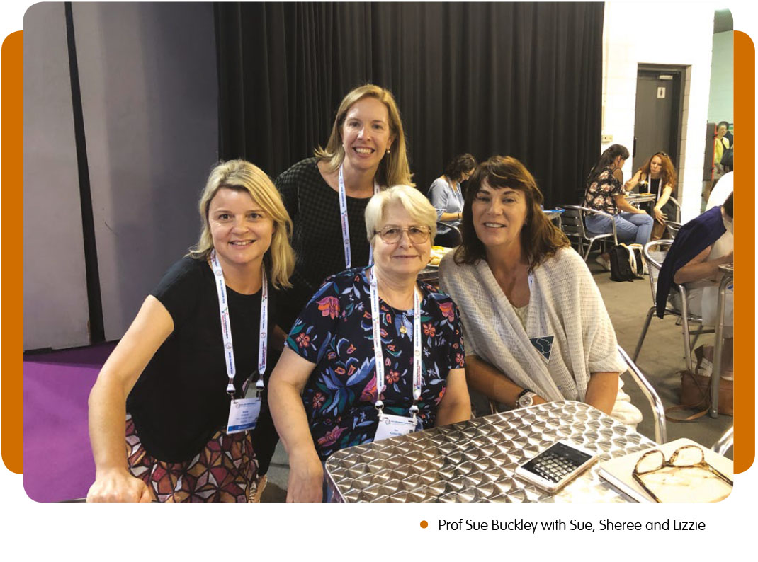

I mean I can’t get my head around why the education system is not inclusive…there is so much written and so much…advice; all schools should have this inclusive model. Then it doesn’t need additional thinking about a child with Down syndrome.
Sheree O’Connor: We support children in mainstream schools from primary, all the way to secondary. Families tell us inclusive education can become more difficult in secondary school.
Sue Buckley:
Yes, but is shouldn’t be.
It’s back to my mantra: ‘A good school is a good school for everybody’ and a good inclusive school should be able to absorb our children. This is a human rights issue. I really think we should be pushing the ‘inclusion for all’ message, that this is good practice for all children…schools should not have an option, they should be doing this.
It’s all to do with attitudes and how you think about things. I find even now, running training sessions in schools, when I say ‘inclusive practice isn’t just about this child’, what we’re saying is: what this child might need is how it should be in this school for everybody. And when you mention the twenty percent and they can think of all the kids they’ve got with different needs – so teachers begin to think differently.
I think it’s a mistake to think that you’re not going to make friends, it just depends on the networks, how in tune people are. We have found even at nine and ten [years old], if children are…standing on their own in the yard at break time and then teachers did something like a computer club that they could go to, they find many other children want to join who want to get off the playground.
I mean none of these things are just to do with having Down syndrome!
Nobody should be on a totally segregated site in my view. It’s all the wrong messages about everything including acceptance of difference.
Sue O’Riley: A final word for parents?
Sue Buckley:
I think parents can only do what their gut feelings suggest is the best for their children.
With your child, at this moment, you have to make what you think is the best placement for them, given your local circumstances. But in the bigger picture, we all need to be fighting for full inclusion in education so they are not faced with those choices.

Further reading
de Graaf G. and de Graaf E. (2016) Development of self-help, language and academics in Down syndrome. Journal of Policy and Practice in Intellectual Disabilities. 13 (2) 120-131.
Guralnick publications:
- http://depts.washington.edu/chdd/guralnick/pdfs/Peer_Related_Social_Competence_1-11_AJIDD.pdf
- http://depts.washington.edu/chdd/guralnick/pdfs/Peer_social_networks-JARID2011.pdf
More information about Prof Sue Buckley OBE including references to some of her many published works in the field of education can be found here: https://www.down-syndrome.org/en-gb/about-dse/people/sue-buckley/
Sue O’Riley is Executive Officer and Sheree O’Connor is Manager of Education at Down Syndrome Victoria.

