There’s no sheltered workshops in Vermont

By Dr Bryan Dague
Vermont is a small rural state in north-eastern United States with the nation’s second-smallest population. The Vermont state motto ‘Freedom and Unity’ aptly describes the culture as seeking balance between the personal freedom and independence of the individual citizen, with the common good of the larger community. Vermont is known for setting trends in terms of progressive social politics and social responsibility. Vermont has also been a progressive leader in disability services as one of the first states to implement community-based employment services, close the state institution, and end sheltered and segregated employment for individuals with intellectual and developmental disabilities (ID/DD).
The movement away from sheltered workshops began in 1980 with a supported employment* demonstration project. Key leaders with the state of Vermont and University of Vermont were driven by the values and belief that people with disabilities deserve to be part of the community like everyone else, not institutionalised or segregated. The supported employment demonstration project called Project Transition started in a sheltered workshop in Barre, Vermont. The project recruited workers from its sheltered workshop to participate in the model demonstration. Staff found community-based employment for workers with support and training from agency job coaches. Project Transition took three to four years to successfully move about 70 people out of the facility into community employment. The success of this demonstration project led to replication sites throughout the state (Vogelsburg, 1986).
Since the initial supported employment demonstration project, inclusive employment of individuals with intellectual and developmental disabilities has steadily increased. The sheltered workshops gradually closed as people found employment in the community or became involved in other community services. In 2002, Vermont closed its last sheltered workshop for people with intellectual and developmental disabilities making Vermont the first state with no sheltered work.

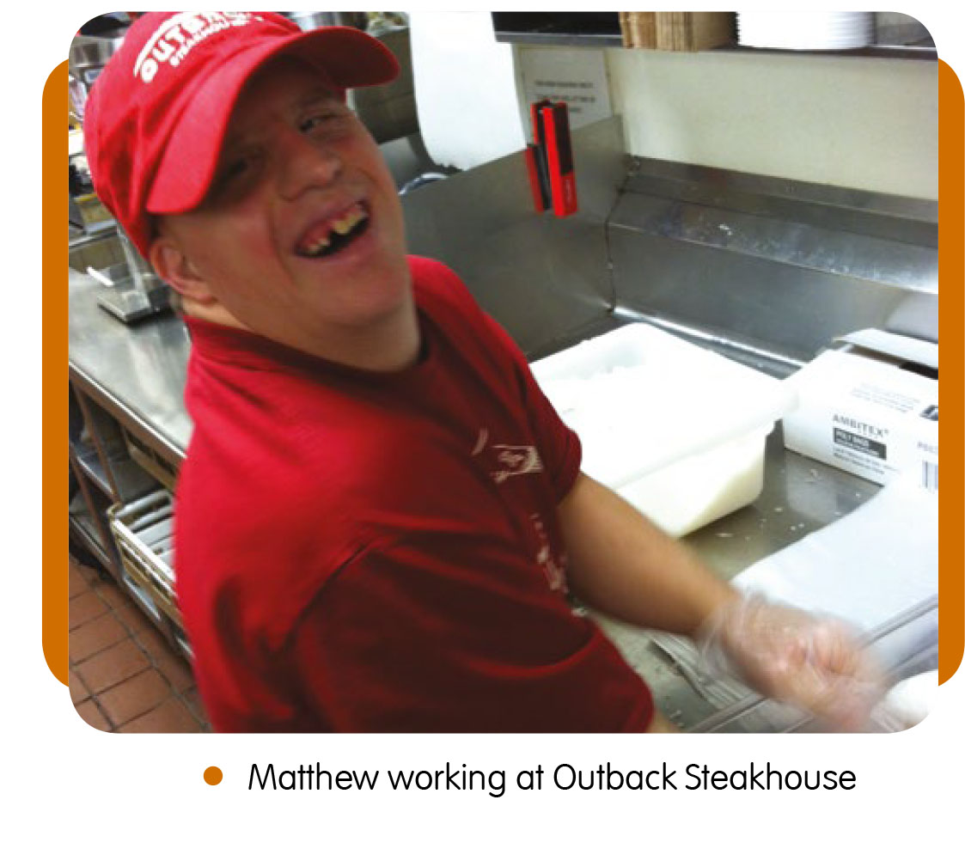 Vermont’s supported employment programs provide a full range of services which enable people with disabilities to access and succeed in competitive employment, including self-employment. Services have been developed from a philosophy that presumes competence and employability of everyone given the proper supports are provided. Person-centered planning, creative job development, meaningful job matches, systematic instruction, assistive technology and natural supports are utilised for full inclusion in the Vermont workforce.
As Vermont moved away from sheltered work, the decision was made to fund only individualised integrated community employment. The state clearly prescribed restrictions in the use of Medicaid dollars for congregate work. ‘We decided we would fund what we believed in and not fund what we did not,’ commented one state leader, ‘That made the difference.’ The state of Vermont recently received international recognition by the Zero Project for Innovative Policy. The Zero Project certified Vermont’s supported employment program as ‘exemplary in the areas of innovation, impact and transferability. The State of Vermont’s Supported Employment Program is outstanding as it facilitates the shift from sheltered employment settings to more inclusive employment for people with developmental disabilities’ (Zero Project, 2017). https://zeroproject.org/policy/long-term-inclusion-in-the-open-labour-market-state-wide/

The shift in philosophy from facility-based to community-based employment services also shifts energy and resources. Since Vermont has no segregated employment, other opportunities are nurtured and supported. One emerging trend is university/college options for students with intellectual and developmental disabilities https://thinkcollege.net. In 2010, the U.S. Department of Education funded 27 grants to colleges to enable them to create or expand high-quality, inclusive-model, comprehensive transistion and postsecondary programs for students with intellectual disabilities. The University of Vermont was awarded one of these grants and developed the Think College Vermont program. Think College Vermont is an innovative, inclusive, academic, social, and vocational program for students with intellectual and developmental disabilities seeking a college experience and career path. Participants earn a 12-credit Certificate of College Studies designed to include academic enrichment, social and recreational activities, independent living and self-advocacy skills, and work experience and career skills. The program incorporates student-centred planning, academic advising, and peer mentors for an inclusive, supportive college experience. The peer mentors are current undergraduate students who provide one-to-one support. There are currently 13 students at the University of Vermont with 30 part-time peer mentors. Mentors provide academic, social, and vocational support.
Individuals with intellectual and developmental disabilities who may have been relegated to sheltered workshops in the past are now attending college and earning certificates. Throughout their two-year college experience, students gain the experience and skills employers are seeking. Students follow a career path and attain better jobs. Program graduates have a 90% employment rate. The success of Think College Vermont has led to the program being replicated at five other Vermont colleges. A number of students with Down syndrome have participated in the Think College program.
Stirling was one of the first students to participate in Think College. She always dreamt about going to college and the Think College program made that a reality for her. She expresses her excitement and anticipation in her video: https://youtu.be/Ajj7RjFWKyA
Stirling’s coursework included Poetry and Film Studies as well as vocational internships at video media services. She is now employed at Green Mountain Self-Advocates and the University of Vermont Think College program as the Media Dissemination Assistant.
Matthew had a strong interest in food systems and helping people in need. His coursework included Farm-to-Table and Introduction to Farming including a vocational internship at the County Emergency Food Shelf. Upon completion of the program he holds two part-time jobs in food service as well as operating his own organic egg business. Matthew states, ‘I love Think College because it gives me a chance to explore new things to know who I am. To find myself and find out what I am capable of. Thanks to Think College I have been a better person.’
Andrew is entering his final year of the program with the spirit and enthusiasm you’d like to see in all college students. His parents say the positive effects of the program are apparent in all aspects of his life. He has learned to ask questions and be curious about his natural surroundings. After taking a Cultural Anthropology course, he started asking his father about his upbringing in England and the foods and traditions he experienced. His parents are very appreciative of the program and the role of the college student mentors: ‘The students have welcomed him with open hearts and made him an integral member of the class and their social lives. We could not have asked for a better situation for him to experience college life.’ Andrew is also co-owner of the dog treat business, Andy’s Dandys http://andysdandysvt.com
The Think College program has had dramatic impact on the students and their families as they have been able to access and benefit from a culture and environment not typically open to them. But the positive impact is not limited to the Think College students. The undergraduate students who serve as peer mentors express what it has meant to them:
‘Being a mentor for Think College Vermont has been the most fulfilling and transformative experience of my college career.’

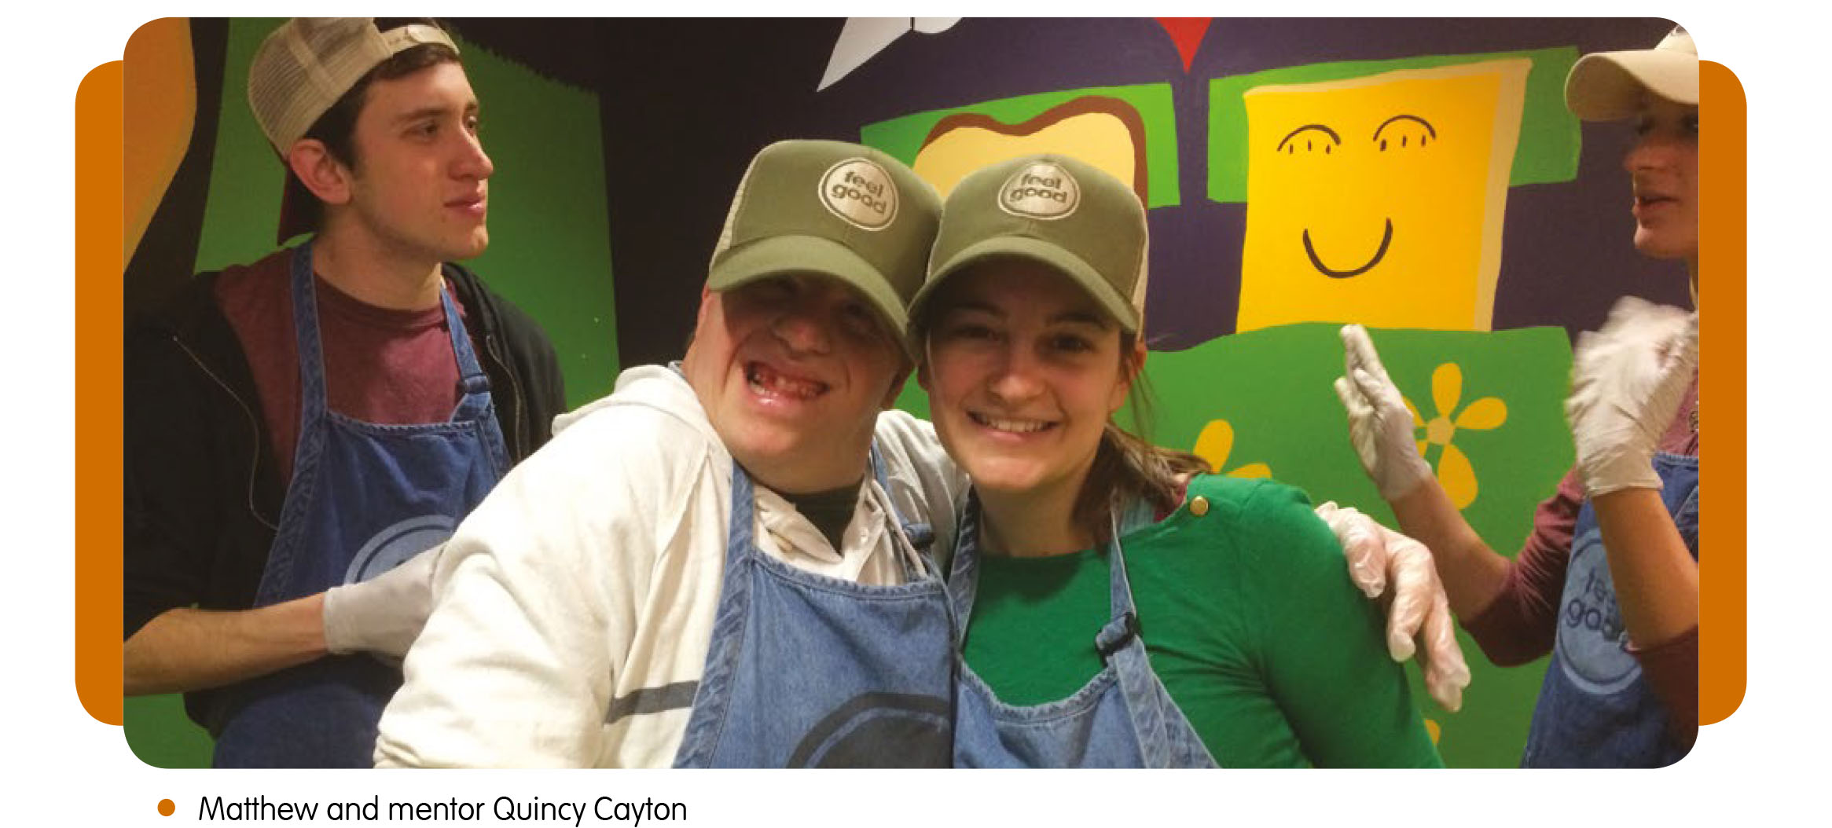

‘I walked into this experience my sophomore year confident that I would be able to make a difference in some of these students’ lives, but after reflecting on my years in this program I can honestly say that they are the ones who have changed my life for the better.’
‘Think College made me full. The joy that filled the days, even on the tough ones, is something I aspire to feel every day. Think College has transformed me into a confident leader and future special educator.’
We have seen that inclusion benefits all of us, sometimes in unexpected ways. As we continue to move toward better inclusion we have learned to start early and to expect more. As we set the bar higher, we see better results.
Dr Bryan Dague is the program director at Think College Vermont, and Research Assistant Professor at Centre on Disability and Community inclusion, University of Vermont, United States of America.
*Editor’s Note: The use of the term supported employment in this article refers to the inclusive open employment program developed in Vermont, where people with a disability are working alongside their peers without a disability. The use of this term in this article does not refer to segregated employment such as Australian Disability Enterprises or sheltered workshops as it is sometimes used in Australia.

References
Dague, B. (2012). Sheltered Employment, Sheltered Lives: Family Perspectives of Conversion to Community-Based Employment. Journal of Vocational Rehabilitation, 37 (1) (2012), 1-11.
Vermont State Annual Report on Developmental Disabilities Services for State Fiscal Year 2014. Disabilities Services Division, Department of Disabilities, Aging and Independent Living, Agency of Human Services, State of Vermont
Vermont State System of Care Plan for Developmental Disabilities (2014). Developmental Disabilities Services Division, Department of Disabilities, Aging and Independent Living, Agency of Human Services, State of Vermont
Vogelsberg, R.T. (1986). Competitive employment in Vermont. In F.R. Rusch (Ed.), Competitive Employment Issues and Strategies. Baltimore: Paul H. Brookes.
Wehman, P. (1986). Competitive employment in Virginia. In F.R. Rusch (Ed.), Competitive employment issues and strategies. Baltimore: Paul H. Brookes.
Zero Project (2017). World Future Council, Geneva, Switzerland
https://zeroproject.org

