What is the DSWA Advisory Network  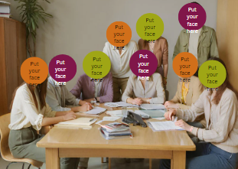 | - It is a group of 12 People with Down Syndrome who meet one time each month.  - They talk about issues that are important to them and other people with Down syndrome.
What will you do…    Listen to others    Talk and share your thoughts    Discuss things together and come up with ideas | - Help the board understand what is important to people with Down Syndrome  - Help the CEO make sure we have programs that people want  - Talk to other people with Down Syndrome to find out what is important to them  - Be speakers at events, activities and workshops about topics we all agree on.
You will come up with ideas   | - You will share your ideas with the CEO (Cassandra) and Board  - The board are parents and other community members who help to run Down syndrome WA.  - You might talk to other people with Down Syndrome  - You might give the CEO or Board advice on issues that are important.  - You will work with others to come up with good ideas to share.
What will I learn if I am on the DSWAAN | - You will learn how to act in a meeting  - You will learn how meetings work  - You will learn about using email and text messages to communicate  - You will learn how to use Microsoft teams on your computer  - You will learn how to work with other people  - You will learn how to listen and then speak about your thoughts  - You will learn how to be a leader
Do I need to already have skills to be a part of the DSWAAN | - The thing you need most is to want to be on the DSWAAN.  - You need to want to learn, share and work with others  - You can communicate in your way  You don’t need experience  You don’t need to be a good speaker  You don’t need to know how to be in a meeting  You don’t need to know how to be a leader  These are all things you will learn
Will I get paid?   | - Being on the DSWAAN you are a Volunteer. Just like being on the board. You don’t get paid for that.  - You do get paid if you come to meetings with us, or come in to do something special like give a speech for us.  - We will explain this more when it happens and make that clear before you agree to help.
Who can apply | - You must be 18 or older  - You can live in Perth or in a Regional Area  - We would like people of all backgrounds and ages over 18 to join.
What support will I have | - You can have a support at home with you.  - We would really like you to answer the questions with your answers  - You will have support of the person the leads the DSWAAN  - You will have the support of your peers – other people with Down syndrome  - We will provide information in a communication method that suits you.
How do I apply   | To apply  Please make a video and answer these questions.  Question 1 - Why you want to join the Down Syndrome WA Advisory Network?  Questions 2 - Tell us something that is important to you about being a person with Down syndrome  Question 3 - What is something you are passionate about or love to do or is important to you?
 | Now what?  You need to send your video to  ceo@downsyndromewa.org.au
Who will choose | The DSWA Board and CEO will choose the new DSWA Advisory Members.
Things you need to know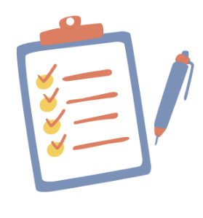 | - You must want to speak about issues that are important to you and other people with Down syndrome.  - You want to help other people with Down syndrome.  - You want to develop leadership skills.  - You will join in at DSWAAN meetings  - You will always come to meetings unless there is an important reason not to  - You need to be willing to listen and to learn to work with others  - Help to set and follow the rules for the Advisory Network members  - Must be able to attend a meeting once a month on Microsoft Teams – Meetings are held on a Wednesday at 10am 2026  - Must actively participate in DSWAAN communication – answer emails, text messages and come to meetings.
 | If you have any questions  Email Cassandra  ceo@downsyndromewa.org.au  or phone  0432 407 527

